Voice Thread

Creating a new Voice Thread

1. Go to www.voicethread.com

2. You will need to register and create an account:
➔ Go to “Sign in” at the top of the page
➔A box will appear; click on “Resgister!”
➔Choose the option at the bottom that says, “Educator? Click Here”
➔Enter your information to create an educator account (note: you will need to wait several days to receive a confirmation email)

3. Once you have your account, click on “sign in” and enter your email address and password.

4. After signing in, click on the tab at the top that says “Create.”

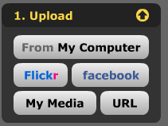
5. Click on the button that says “Upload” and then choose “From My Computer.”

6. When the window opens, choose the location of your picture and then click “Select.”
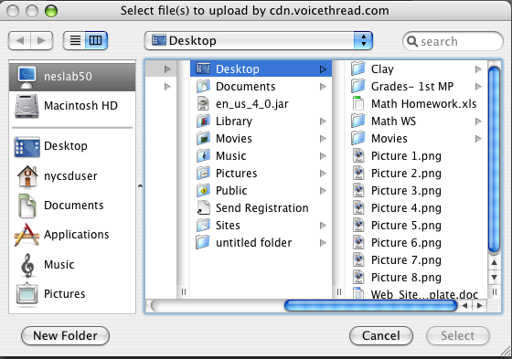

7. Your picture will now be displayed in VoiceThread. You can repeat steps 5 and 6 if you would like to use several pictures.
8. Select the picture you want to use by clicking on it. Then, click the “Comment” button on the left menu.
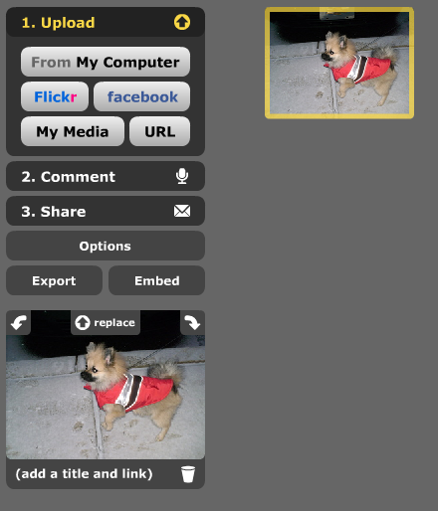

9. When the picture appears, click 10. Now click “Record” and begin
on “Comment” again in the middle speaking. Press “Stop Recording”
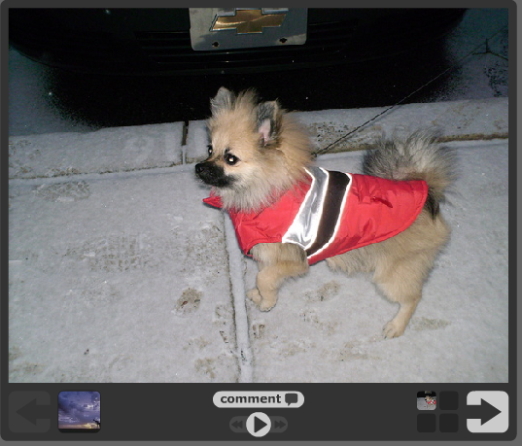
of the screen. when you are finished
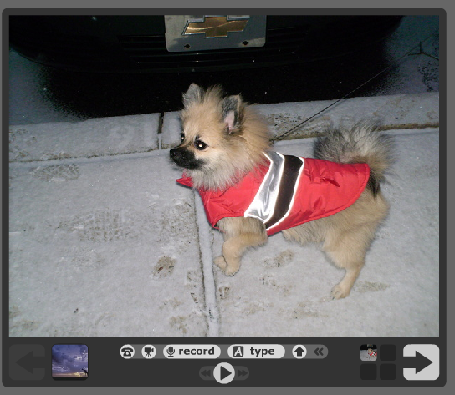

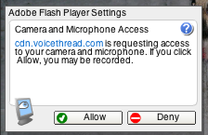
Note: When you click “Record” this box may pop up. You need to click “Allow” to begin recording.

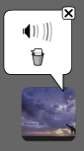

11. If you are satisfied with your recording, click “Save.” To try again, click “Cancel” and re-record. If you clicked “Save” but you need to erase the comment, click on your icon to the right of your picture. Then, click on the trashcan to delete the comment.

12. To advance to the next picture, simple click the arrow in the bottom right corner.

13. You can add a title to your VoiceThread by clicking “Add Title” at the top of the screen.

Putting a VoiceThread video on your website

When you create a VoiceThread video, it is hosted online only. To place it on your website, follow these steps.

1. On the left menu, click “Share.” You will see the Sharing Options to the right.
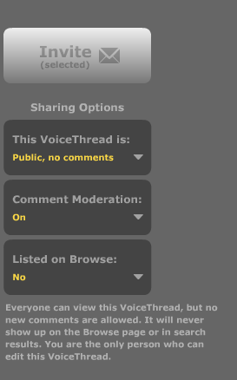

Change the top box to “Public, no comments.”

Change Comment Moderation to “On.”

Change Listed on Browse to “No.”

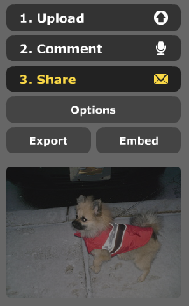

2. Back on the left-hand menu, click “Embed” (found under “Share”).

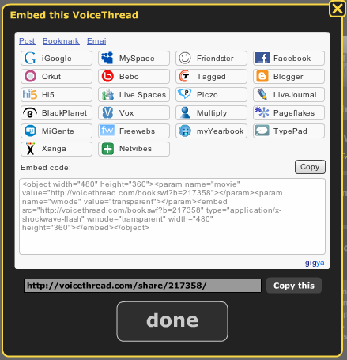
3. When the embedding window pops up, click copy next to the embedded code.

4. Log into your SchoolWorld website.

5. Click on the page where you will add your VoiceThread video.

6. At the bottom of the page there are two tabs; click on the “HTML” tab.
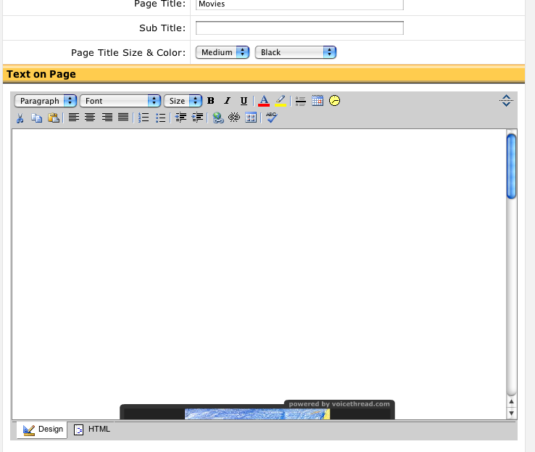

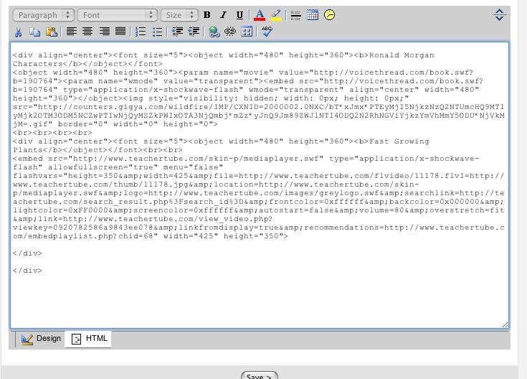

7. Paste the video code by holding the Apple key and “V” or by going to “Edit” and the “Paste” on the toolbar. You will see a large amount of text appear. Make sure you click “Save” at the bottom of the page. When you view your site, the video should appear.

Creating Multiple Users

You can have your class create a VoiceThread on one computer by simply taking turns. However, it is possible to have everyone create their own using the same account.

1. Create an identify for each student or group of students. Log-on to your VoiceThread Account.

2. On the top toolbar, click on the picture that has your name.

3. On the drop-down menu, click “My Account.”

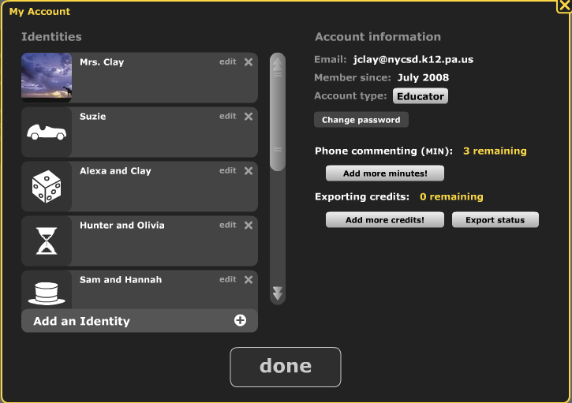
4. At the bottom of the window, click “Add Identity.” (Note” this is also where you can make changes to your account, like changing your password if you would need to).

5. In the pop-up window, type the name (first only!) of the student or students. You can also click “select an image” to choose an icon that will represent that group. When you are finished, click “Save.”
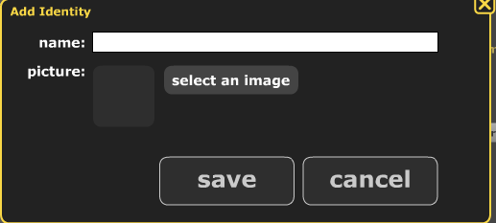

6. The students can each log onto your VoiceThread account (you will need to give them your email address and password). They follow the same procedures for creating a VoiceThread. When they begin to make a comment, they can click on the icon in the bottom left corer and choose that one that has their name.

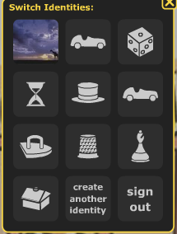

7. The students can save their individual videos the same as
you would. You can embed them later.

Using the Doodler

You can actually write on the picture as you speak to demonstrate something. It’s simple!

1. After you click on “Record” you will see a color circle to the left.

2. Simple choose a color and a pencil will appear. You can write by clicking and dragging the mouse.


3. To make the drawing stay, click on the white circle in the center of the colors (otherwise the drawing will fade away).



